**Login Screens**

[**Figma link**](https://www.figma.com/proto/dMXhoiB3u4AD4y1rnKWZV0/CRM-Working-file?node-id=3124-5538&viewport=93%2C-1553%2C0.04&t=BESIdr4CzkbUuWJP-0&scaling=min-zoom&content-scaling=fixed&starting-point-node-id=3124%3A5538)

**#Sample 1**

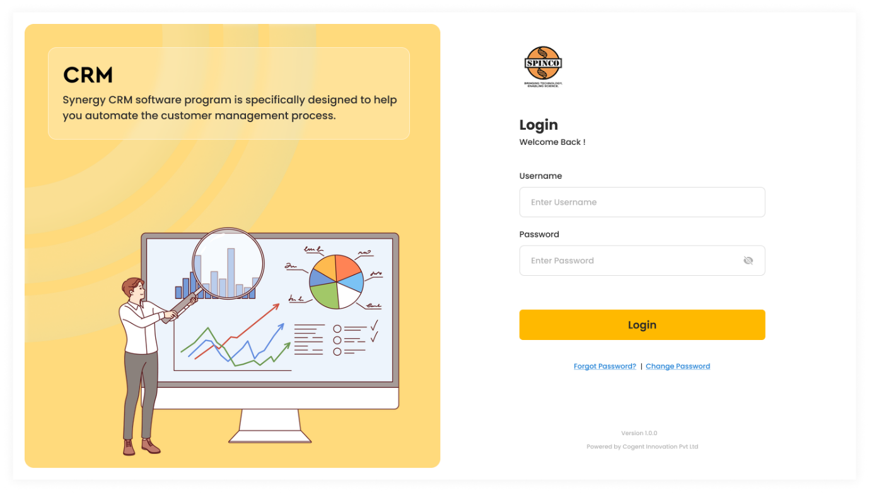

**#Sample 2**

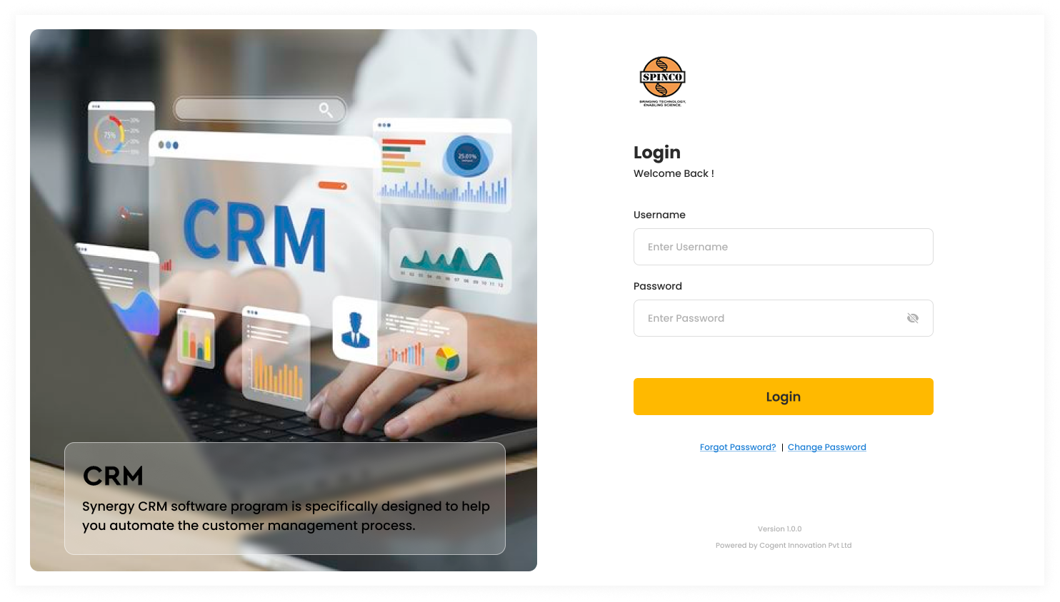

**#Sample 3**

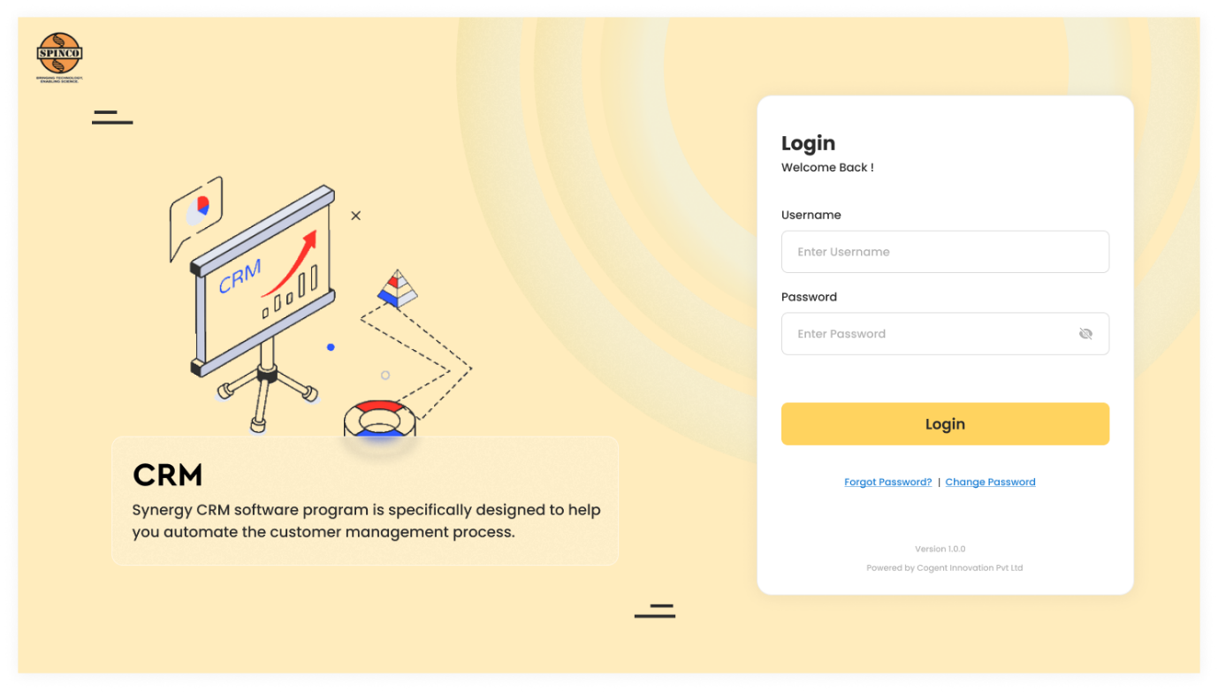

**#Sample 4**

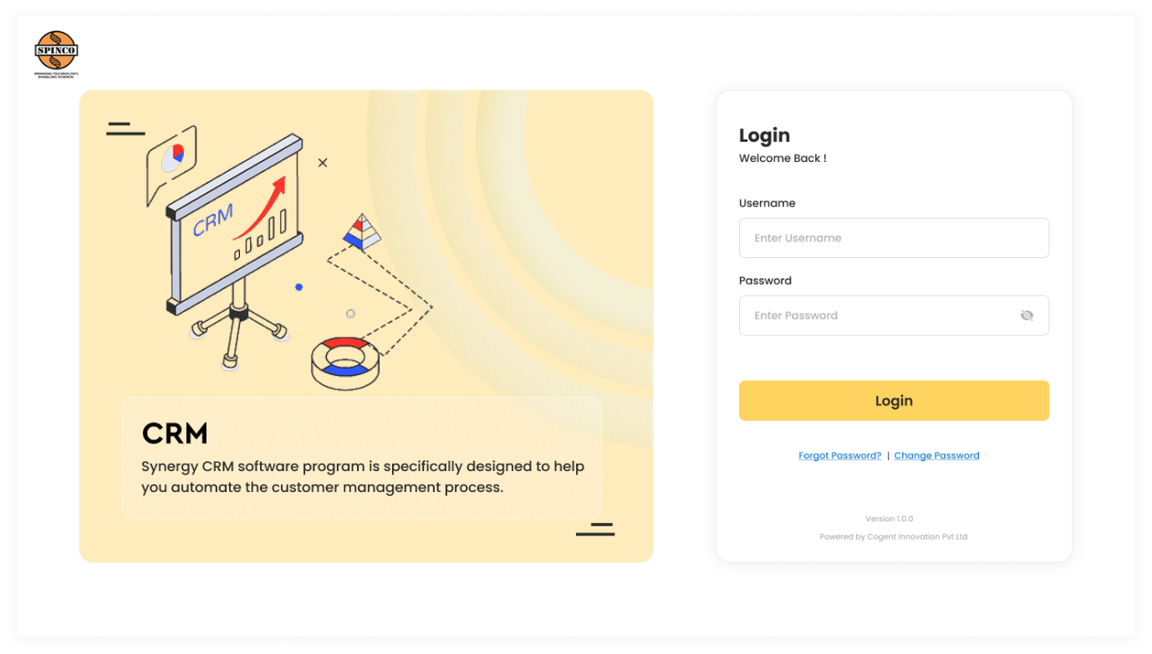

**#Sample 5**

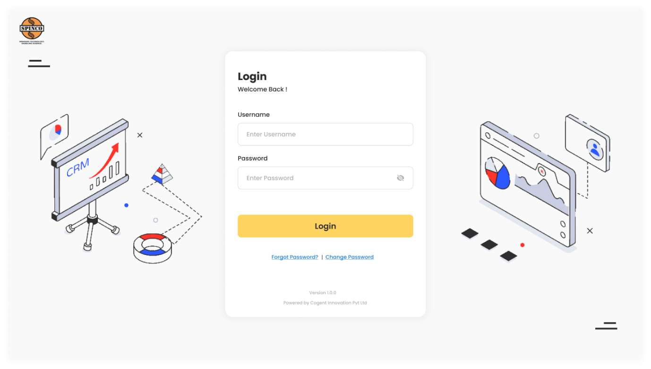

**#Sample 6**

